Effect Size Guide

Two independent means:

* Applies to independent t-tests, post hocs tests for between subjects IVs
* You need means, standard deviations, and n for each group
* Also included how to get the values from t given you are trying to calculate from a research article (for sample size planning).

|  |  |
| --- | --- |
| Cohen’s *d* (traditional formula) |  |
| Cohen’s *d* (most used formula) | where SD is pooled: |
| Glass Δ | Where standard deviation is for the control group. |
| Hedge’s *g* (bias correction on Cohen’s *d*) | First calculate Cohen’s *d* most used formula.    Where *g* = *d* that you just calculated. |
| From *t* values |  |
| From *t* values | $$\frac{2t}{\sqrt{df}}$$ |

Where do I get all these numbers? First, run your test for independent *t*. (ANOVA to be added later).

* Analyze > Compare means > independent samples t
* Move over your DV into the test variables box.
* Move over your IV into grouping variable box.
* Hit define groups, list in the numerical values for your groups.
* Hit continue and ok!

|  |  |  |  |  |  |
| --- | --- | --- | --- | --- | --- |
| **Group Statistics** | | | | | |
|  | Cloak of invisibility | N | Mean | Std. Deviation | Std. Error Mean |
| Mischievous Acts | No Cloak | 12 | 3.75 | 1.913 | .552 |
| Cloak | 12 | 5.00 | 1.651 | .477 |

N values Xbar values S values

Notes: if you do the formulas by hand:

* You’ll need to square the S values, the formulas represents *variance*, while SPSS gives you *standard deviation*.
* Does not matter which one you put first (traditionally people list Cohen’s *d* as positive no matter what).
* Don’t use SE in these formulas. Unless *t* = 0, then *d* should always be smaller than *t*.
* If n = n for groups, then you can just average standard deviations together.
* Sometimes, the *t* formula can be biased based on group sizes (the second one especially).

From *t*:

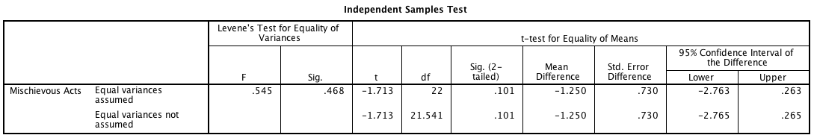

t value df

Two dependent means:

* Applies to dependent (paired) t-tests, post hocs tests for repeated measures IVs
* You need means, standard deviations, and n for each group
* Also included how to get the values from t given you are trying to calculate from a research article (for sample size planning).

|  |  |
| --- | --- |
| Cohen’s *d* (traditional formula) | $$\frac{Mdifference}{Sdifference}$$ |
| Cohen’s *d* (suggested non-biased formula) | $$\frac{Mdifference}{({S1+S2)}/2}$$ |
| From *t* values | $$\frac{t}{\sqrt{N}}$$ |

Notes:

* Mdifference = Mean measurement 1 – mean measurement 2
* Again these are traditionally listed as positive, even if t, mdifference are negative
* S1 and S2 are standard deviations for each measurement point
  + You do not have to pool them (as above) because N is equal.

Where do I get all these numbers? First, run your test for independent *t*. (ANOVA to be added later).

* Analyze > Compare means > paired samples t
* Move over your two measurements into the test variables box.
* Hit ok!

|  |  |  |  |  |  |
| --- | --- | --- | --- | --- | --- |
| **Paired Samples Statistics** | | | | | |
|  | | Mean | N | Std. Deviation | Std. Error Mean |
| Pair 1 | Mischief (No Invisibility Cloak) | 3.75 | 12 | 1.913 | .552 |
| Mischief (Invisibility Cloak) | 5.00 | 12 | 1.651 | .477 |

Means N Standard deviation (S)

Notes: Remember that N is only used once since people are in both measurement levels.

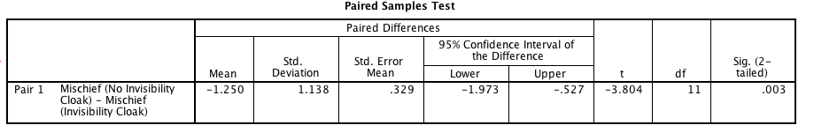

M difference S difference t value df

Notes:

* Do not use SE in these formulas, remember that *d* should be less than *t* unless *t* = 0.
* Since formulas will give you very different answers depending on sample size, you should list which denominator you used (i.e. Cohen’s *d* based on standard deviation of difference scores, or Cohen’s *d* based on average standard deviation of measurements/times).

Three or more means:

* Applies to ANOVA: all types (repeated or between or mixed).
* You need SS values or df values and F.

|  |  |  |
| --- | --- | --- |
| R2 | Proportion of variability accounted for by an effect  Useful when you have more than two means, gives you the total good variance with 3+ means  Small = .01, medium = .06, large = .15  Can only be positive  Range from .00 – 1.00 | More commonly used in regression, correlation  R2 = SSModel/SStotal  Also can been found at the bottom of the ANOVA box in SPSS |
| Eta squared ɳ2 | Same as above.  SPSS for 1-factor ANOVA eta and R2 are same. | More commonly used in ANOVA as overall effect size  ɳ2 = SSModel/SStotal  Also can been found in ANOVA box if options are selected |
| Partial eta squared ɳp2 | Same as above.  Here the effects are estimated based on the effect and error together (different denominator)  Useful with repeated measures designs and multiple factor designs, as it estimates for each effect | More commonly used in ANOVA as individual effect size  ɳp2 = SSIV/(SSerror + SSIV)  Also can been found in ANOVA box if options are selected |
| Omega squared ω2 | R2 and d tend to overestimate effect size  Omega squared is an R2 style effect size (variance accounted for) that estimates effect size on population parameters | Formula =  SSM – (dfM)*MSR  SStotal + MSR  If this value is negative, you say that omega squared is zero |
| Partial omega squared ω 2 | Omega squared counterpart that is used to indicate the effect size for contrasts (i.e. pairwise comparisons) in ANOVA  Similar to d | Same formula, using the contrast F-values (would need to use ANOVA post hoc running only two groups at a time). |

One way output:

* Analyze > compare means > one way anova
* Put DV in the dependent list
* Put IV in the factor box

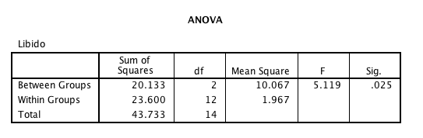

SS df MS

Notes:

* Remember that between groups = model, within groups = residual, total = total

GLM output:

* Analyze > general linear model > univariate
* Dependent variable = DV
* Fixed factor = IV
* Click options > estimates of effect size

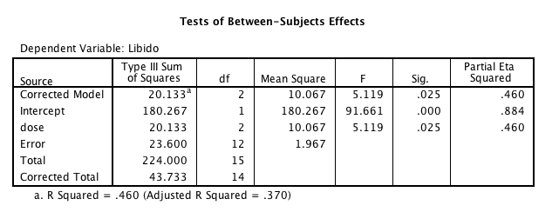

SS Total df eta squared

Notes:

* Only partial eta when there are multiple IVs
* Be sure to ignore corrected model, intercept, and total lines.

Repeated measures designs:

|  |  |  |
| --- | --- | --- |
| R2 | Proportion of variability accounted for by an effect  Useful when you have more than two means, gives you the total good variance with 3+ means  Small = .01, medium = .06, large = .15  Can only be positive  Range from .00 – 1.00 | More commonly used in regression, correlation  R2 = SSModel/SStotal  Also can been found at the bottom of the ANOVA box in SPSS |
| Eta squared ɳ2 | Same as above.  SPSS for 1-factor ANOVA eta and R2 are same. | More commonly used in ANOVA as overall effect size  ɳ2 = SSModel/SStotal  Also can been found in ANOVA box if options are selected |
| Partial eta squared ɳp2 | Same as above.  Here the effects are estimated based on the effect and error together (different denominator)  Useful with repeated measures designs and multiple factor designs, as it estimates for each effect | More commonly used in ANOVA as individual effect size  ɳp2 = SSIV/(SSerror + SSIV)  Also can been found in ANOVA box if options are selected |
| Omega squared ω2 | R2 and d tend to overestimate effect size  Omega squared is an R2 style effect size (variance accounted for) that estimates effect size on population parameters | Formula =    a = levels (a-1) = dfmodel  n = number of people in each level |
| Partial omega squared ω 2 | Omega squared counterpart that is used to indicate the effect size for contrasts (i.e. pairwise comparisons) in ANOVA  Similar to d | Same formula, using the contrast F-values (would need to use ANOVA post hoc running only two groups at a time). |

GLM output:

* Analyze > general linear model > repeated measures
* Create an IV name + levels > hit add and define
* Move over the variables in order to the 1, 2, 3, … under within subjects variables
* Click options > estimates of effect size

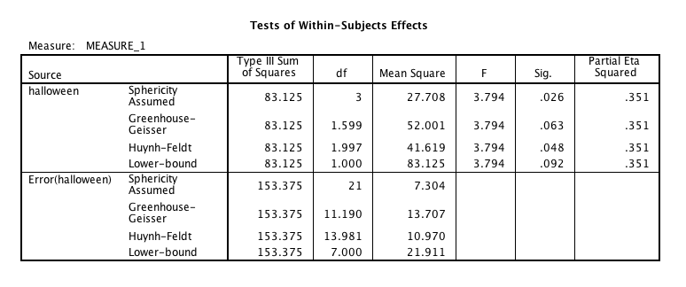

dfm F eta

Notes:

* Remember partial eta = eta = R squared are all the same in a one-way design.
* Same rules/steps to get effect sizes or numbers to calculate omega when you use a two-way design, just be sure to use the right lines (dfM for variable 1, F for variable 1, etc.).